How to Draw a Portrait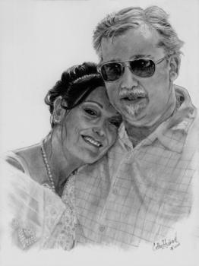
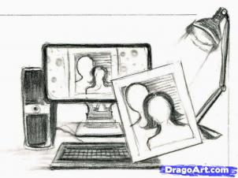

Step 1.
THE FIRST SIX STEPS in this tutorial are about TIPS & TOOLS. A great portrait needs an excellent photo and pose,which is drawn from torso up or the head only. On the photo, you need to see reflections and the white in the subject’s eyes clearly. Traditionally, the subject is posed sitting erect facing or partly facing you. The light falls on the subject from the front onto one side of the face. The photo should be taken without a flash, which washes out shading. The subject’s face is at least one and a half inches wide on the photo. Also all of the subject is in focus: clear and detailed, especially the face. You can also scan the photo onto your computer and enlarge to work on details.

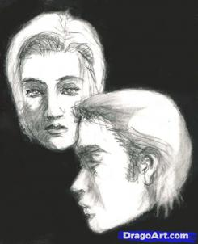

Step 2.
LIGHTING! Remember in the above lesson we talked about it? Here's some more tips. GREAT LIGHTING! The most commonly used lighting angle for portrait drawing is at 45 degrees and is called conventional lighting. The lamp is placed to the side, above the subject and slightly toward the foreground. This helps bring out the features of the face with nice shadows like the man and girl pictured to the right in the drawing. INFERIOR LIGHTING. Direct sunlight, bright light from behind (silhouette), light from one side of face cuts it in half. These lighting scenarios makes inferior portrait settings.

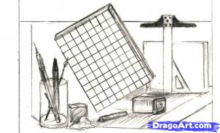

Step 3.
TOOLS! I'm introducing the grid. It's a great way to transfer the picture onto your paper with accuracy and speed. Draw the square grids on your ref picture printout (they could be one inch squares). Count how many in the column and row. Then you can use the same count of squares in your column and row. But the fun thing is you can scale your picture larger by doubling, tripling the square sizes. T-SQUARE and TRIANGLE makes straight lines or squares... great for doing the grids. Remember your mechanical pencil(s) at 0.7mm using HB or 2B. Your graphite pencils are great at 9B (black, bold, and smooth). Electric pencil sharpener, kneaded eraser, blending stumps/tools, and for easy highlights, white acrylic and paintbrush. Don't nod on me, now. Keep going because we're just getting started.

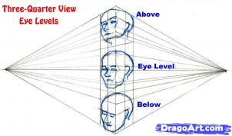

Step 4.
In the portrait drawing, you are using THREE-QUARTERS VIEW (3/4). The picture shows us the 3/4 view at different eye levels. The ears are a great focal point of what eye level you are viewing, which is above, at eye level, and below. According to perspective, notice how the ears stay in line with the eyebrows and nose of the face.

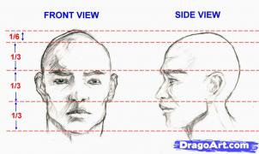

Step 5.
FRONT and SIDE VIEWS! Oh that nasty word...proportions! The 4th and 5th step helps with proportions of the face. As a norm, with adjustments, the face is divided into thirds. From hairline to eyebrows, eyebrows to nose tip, nose tip to chin. FRONT VIEW - The space between the eyes take up one eye. The mouth extends a bit further from the nose. And the hairline to top of head is one sixth(hehehe... I've noticed a lot of guys have that little hump at the crown of their head). SIDE VIEW - The eyebrows and nose position are about the same. The ears are at the same level. The mouth extend a tiny bit further than the nostrils. The front and side view are at EYE LEVEL. Every individual is different. From this base, you can tweak your drawing to the likeness of the subject. ARE YOU READY TO DRAW??? Come on, let's get to it. The remaining steps are focused on your drawing the portrait!

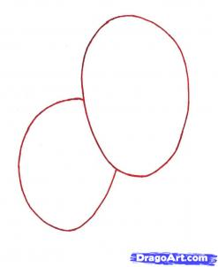

Step 6.
Decide at this point if you're drawing the heads larger, or doing the whole head and torso. If you do the heads larger, then the heads will take up three fourths of the page. Work the heads on 8-1/2 to 11 inch paper (A4-typing/printer paper size). I suggest you work on the larger heads. If you want to tackle the whole picture, your faces will be smaller and more challenging to fill in the details. ***Draw in the ovals lightly. It is important to stay with the shape because they are not perfect ovals.

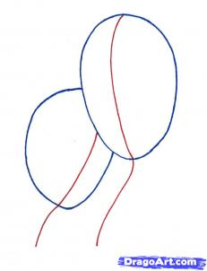

Step 7.
Draw with you pencil lightly the snake-like centering lines. They help keep the centering of the face, neck placement and torso.

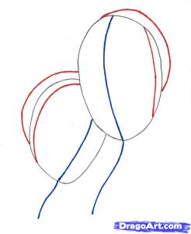

Step 8.
The first strange crescent shape represents where the ear begins, sideburns, and crown of hair (where my friend's pearl headband is). The second curve represents the back of their heads. This will help with the volume of the hair mass.

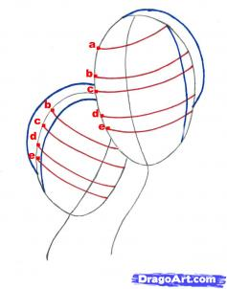

Step 9.
Draw in lightly these bowed guidelines on the face. This reminds me of a fencing mask, minus the mesh. The marked area (a) is the hairline on the new husband's face. On both faces are placements for: (b) Eyebrows, (c) Eyes, (d) Bottom of nose, (e) Middle of mouth. The curvature of the guidelines help with the perspective of the faces. Take your time in drawing these lines. They help so much getting your proportions and even likeness of a person.

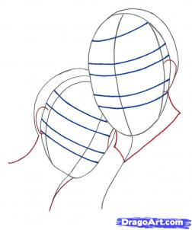

Step 10.
You have worked hard placing those lines in the right place. So this step is a lot easier. Draw in the ears near the eyes and the mouth guidelines. Look closely at the ear placement to see if you drew them in correctly. Also add the neck lines.

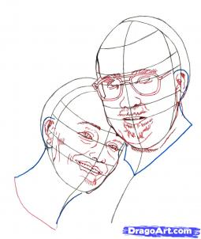

Step 11.
Clap your hands everybody. Shake them. Relax them. We are now venturing into the fun part. Their faces. Start from the left side (my friend) and put a piece of paper or napkin under your hand as not to smudge the paper. Draw in her features lightly, then work your way over to her new husband. Draw in his eyeglasses. See where they are in relationship to the guidelines. Note his eyebrows are directly under the eyebrow line. His eyes are near the middle of the lines. Do not fill in his eyes with pupils. Draw his nose because that will help with the placement of the bottom of his sunglasses. Work in his mustache, mouth, and beard. Lightly draw in those cute curly lines of his facial hair. Make sure you add the details of his jaw, back of neck, and lower chin(s).

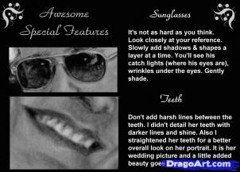

Step 12.
Relax and stretch your fingers. Snack and drink some water, coffee, tea, or soda. You are ready to tackle eyeglasses and teeth of all things! My advice is take it slow and easy. Mold your picture. That means erasing, redrawing, and finding your perspective. Look at the picture, shade gently with a 2HB pencil to get the basic forms. Remember, this is all lines and shadows. CLICK ON THE PIC to read my tips!

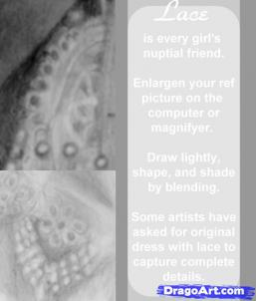

Step 13.
LACE! Look at the picture. Click on the pic to read my tips. It takes patience and a fearless resolve. Attack it with an artist eye and have fun. You may have once thought you could never do lace. Now you are conquering that unknown. Find the basic shape and mold it with light circular strokes and shading. Remember, this is not High Definition of photo-realistic drawings. That's another story!

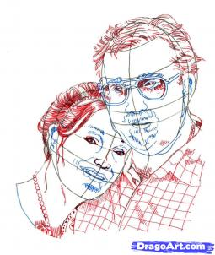

Step 14.
This is where you sketch out more lines in their hair, eyes, nose, pearl necklace and his shirt. I work a certain way in drawing and you may have a specific way. Go with it. But to help someone who could be baffled at doing two heads at the same time.... relax! Take your time. What I do is work on each head a layer at a time. I sketch in the outline first her then him, balancing them both to look like each other. Then I add more details and shading to her first (about mid tone) and then I add his. Now seriously, I haven't worked on the clothes yet... the clothes do have the first layer done. After the second layer is done on their faces and hair, I start a third layer on their hair. Then I work on a second layer on the clothes. This is to break up boredom. If you get bored easily and tired, you may need to jump around to spark your interest on how your subject will look.

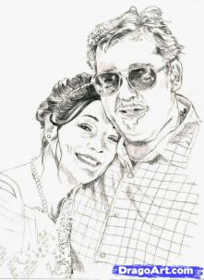

Step 15.
This can be considered a first layer applied everywhere and a second layer on their faces and hair. You can tell their skin has not been completely shaded in, neither has their clothes. Normally, it is good to start with shading in their faces and do a third layer on their hair. At this moment on your drawing, you should feel accomplished and start on shading the lacework and shirt. Let me tell you the hair and clothes can take as much time as their faces. Why? I say that the clothes and hair has as much personality as the subject.

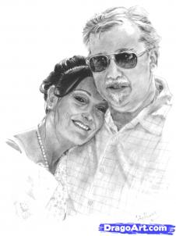

Step 16.
Now you've added more shades, highlights patiently. Look at your end product. It's worthy to be framed because this is a piece of art. Lines of dark and light have meshed together from chaos to serenity and beauty. Whether it looks like my picture or two major lines representing my friend and her new hubby, your picture is art interpretation. Enjoy your creation because it came from your hands. I hope this has been helpful and memorable. Let me know what you created. Submit your artwork here at Dragoart if you can. You've worked hard on it and deserve a compliment or two from your friends. Much love and peace to you all!

http://www.dragoart.com/tuts/7198/1/1/how-to-draw-a-portrait.htm

